Axis camera station Pro Prerequisites & Installation Guide
Axis Camera Station vs Axis Camera Station Pro
- Platform
  - Both are VMS applications from Axis.
  - Core functionality (device management, recording, alarm handling, etc.) is the same.
- Port
  - ACS Pro: Always uses port 29204 (non-changeable).
- Client
  - ACS and ACS Pro have different client executables.
  - Even though the backend logic is the same, the client binaries are separate.
  - This is why they are seen as different applications when installed/launched.
- Integration (GCX-ONE)
  - From an integration perspective, both are treated the same, except for:
    - Port handling (ACS Pro fixed at 29204).
    - Client reference (different executable).

Note : The below prerequisite configuration steps are for admin users for troubleshooting and configuration purpose

1. Prerequisites
Before proceeding, ensure the following:
- You have administrator privileges on your system.
- Your system meets the minimum hardware and OS requirements for the installer.
- Network access to the target AxiscamerastationPro device is available

2. Install Axis Camera Station Pro Software
- Download Installer
🔗 Download
AXIS Camera Station Pro - Update for server and client
2. Run the Installer
  - Click the downloaded .exe file.
  - Proceed with default options unless specified by IT policies.
  - Finish installation and launch the application.

Once installed, the 'Welcome to Axis Camera Station Pro' pop-up will appear.

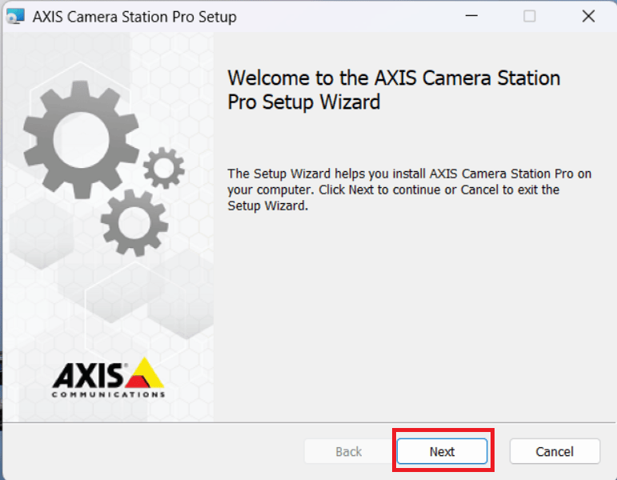
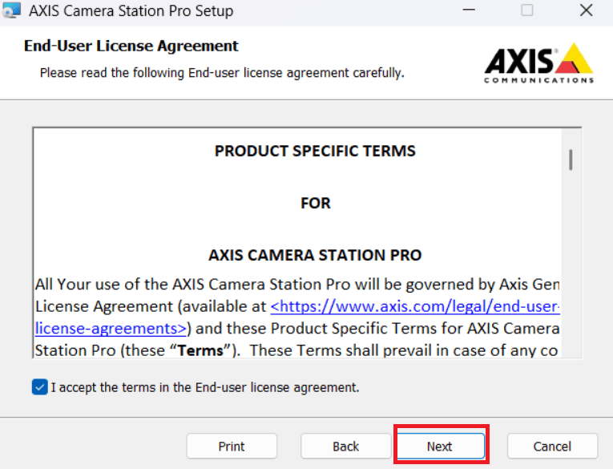
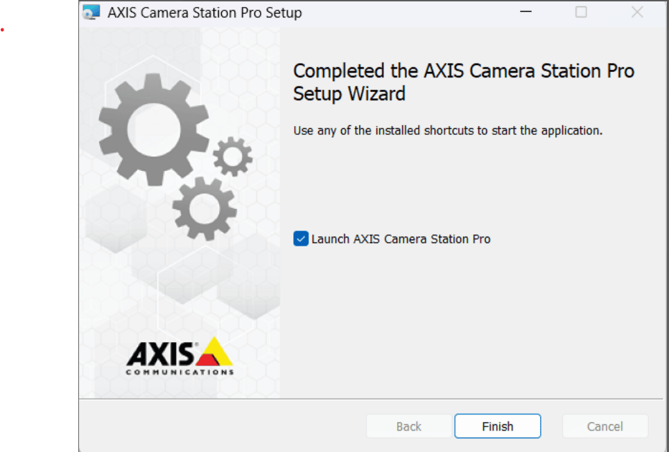
Once installed successfully you will be able to see the client on your desktop (or mentioned in your path).
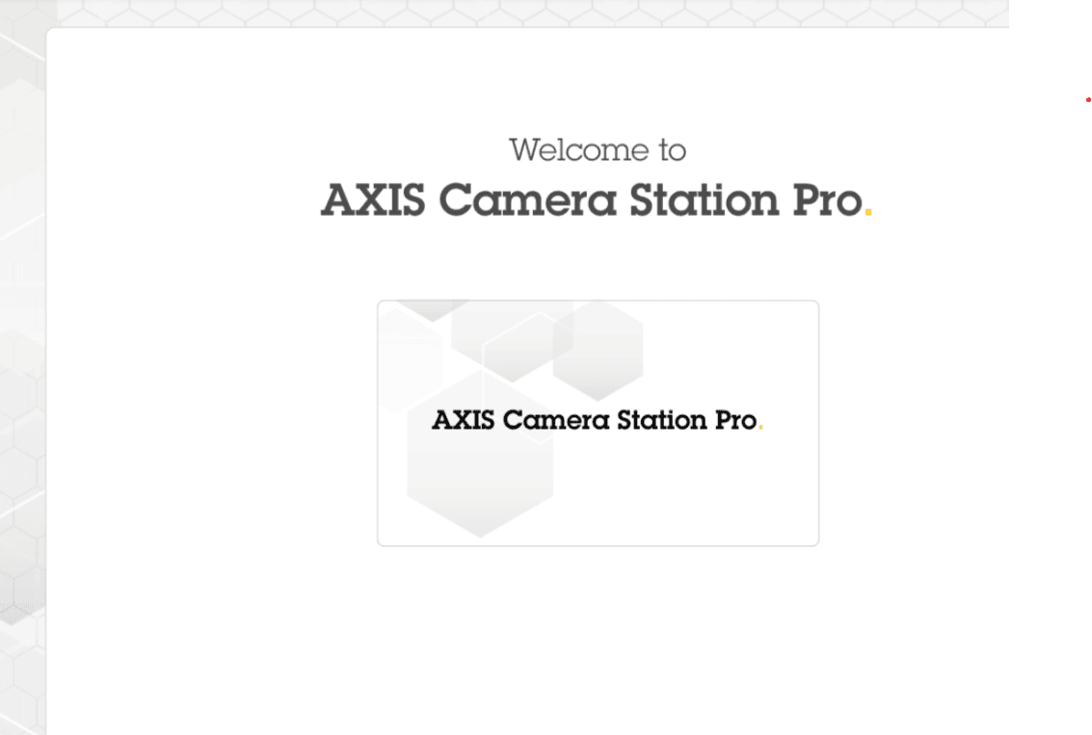Upon opening the client you will asked for the authorization with IP Address,username,password and able to see the live stream.
Step : 1. Click to Manual search Open pop up Enter the IP Address.

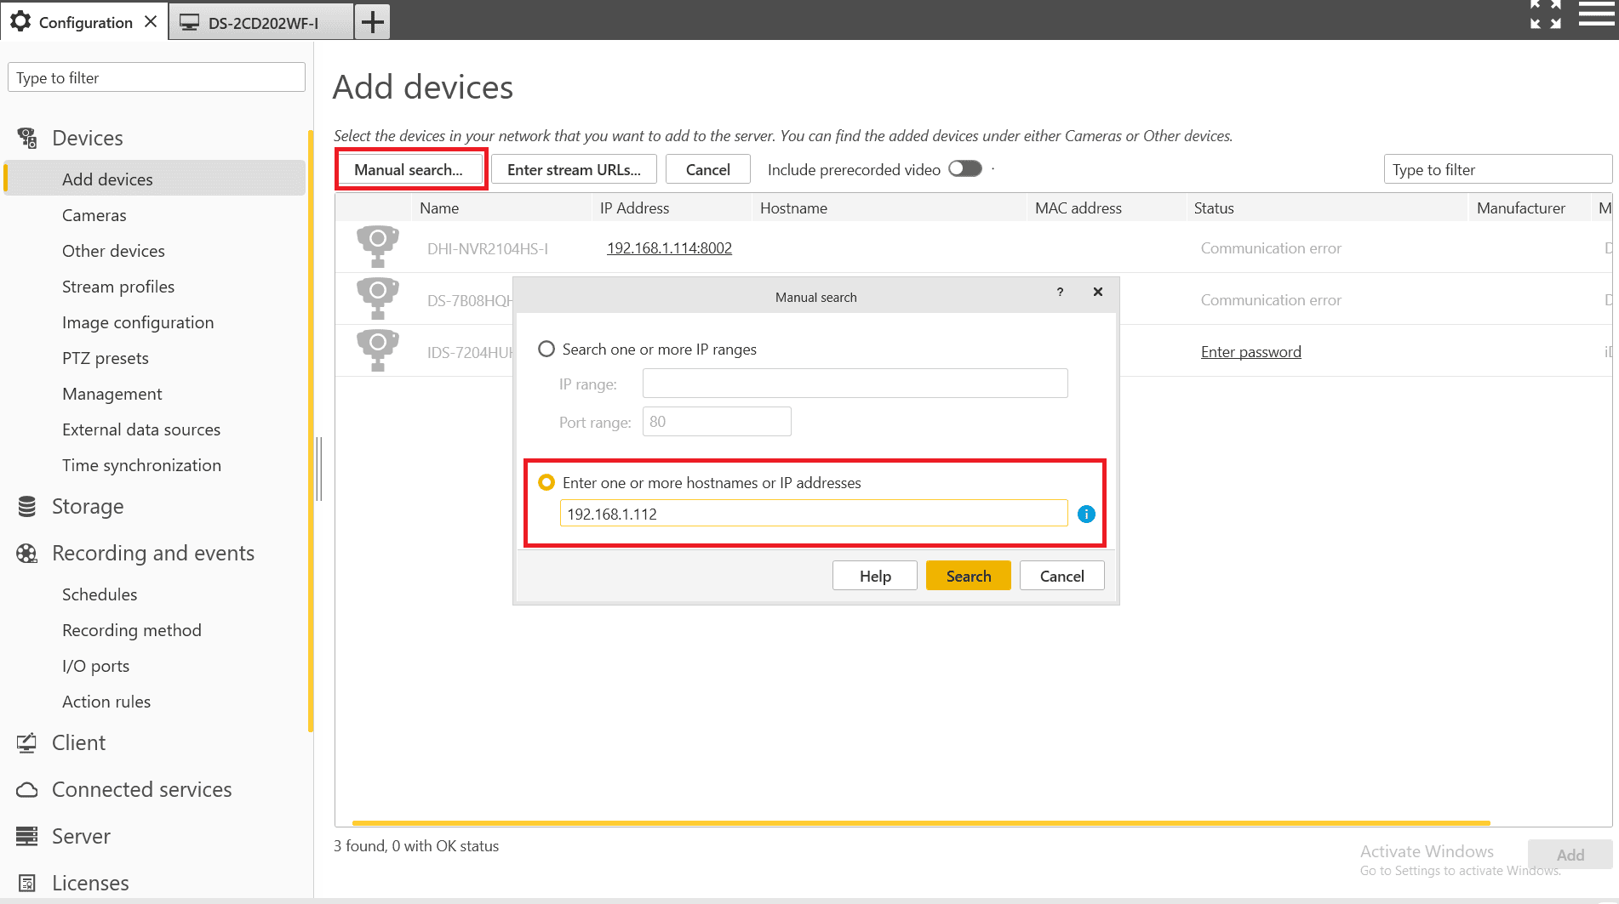
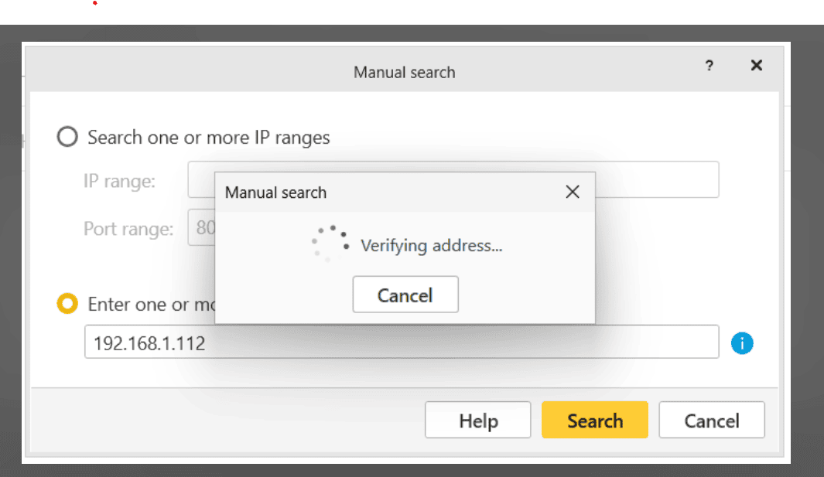

Step 2 : Enter the Username and Password :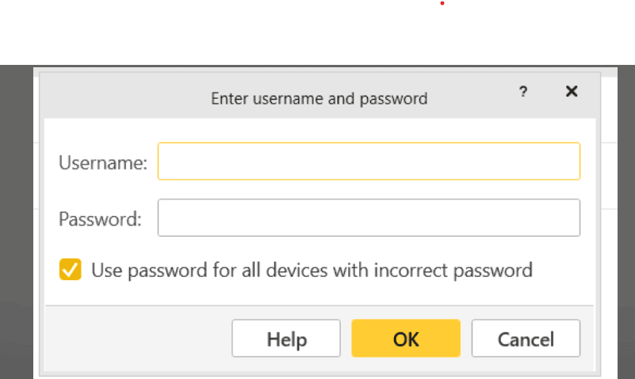
Verify device Credentials :
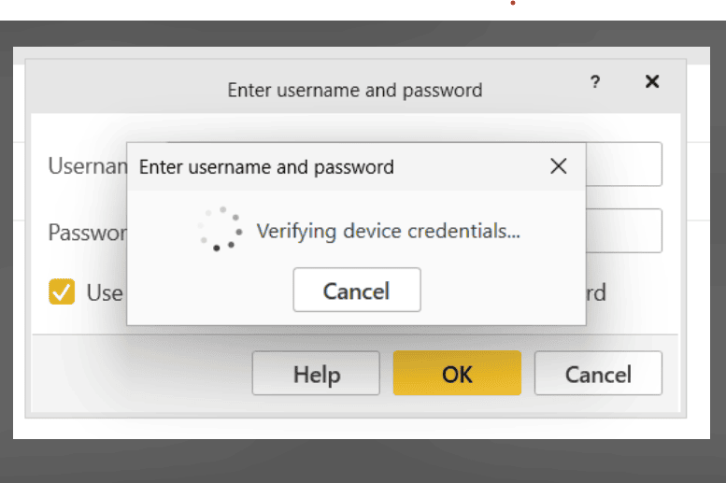
Step 3 : Click the devices and Add :
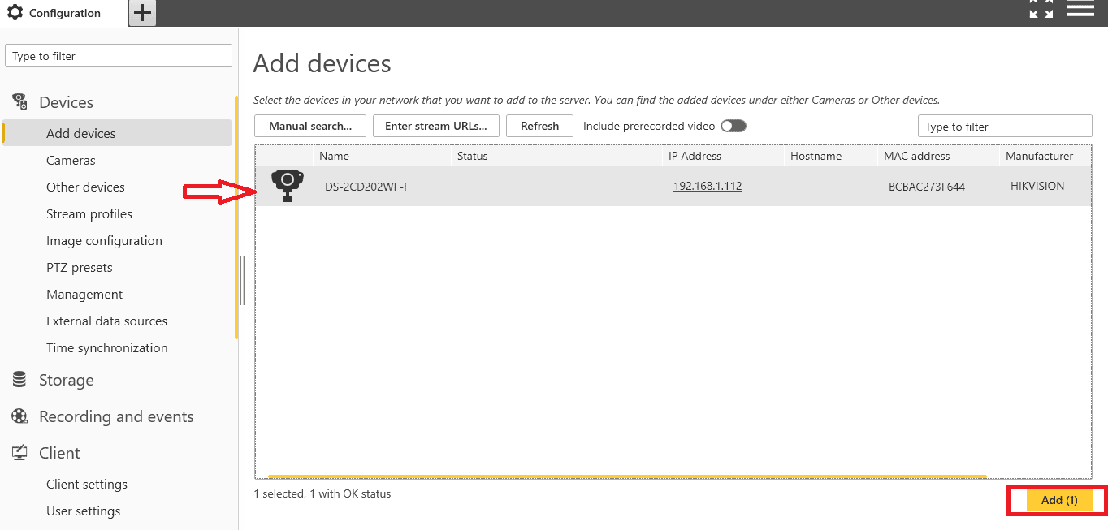

Step 4 : Click to Next :
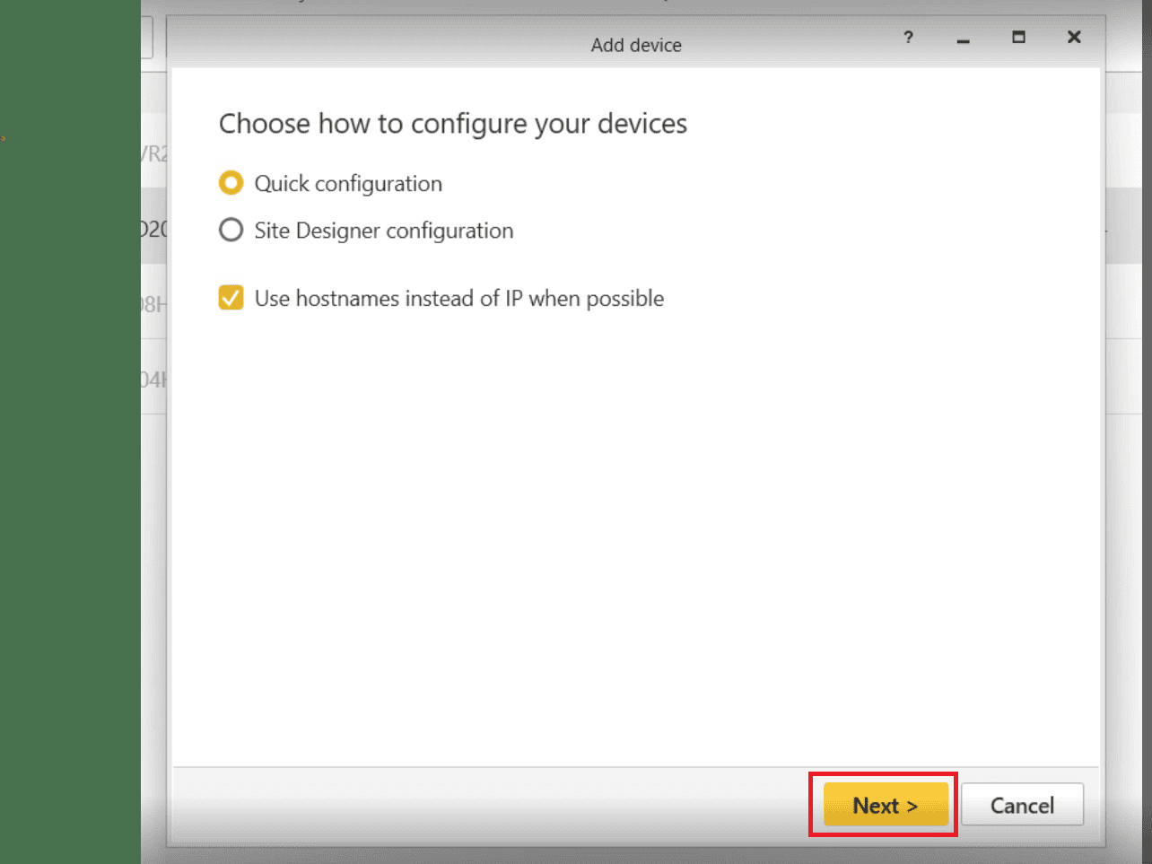
Step 5 : Click to Install the devices :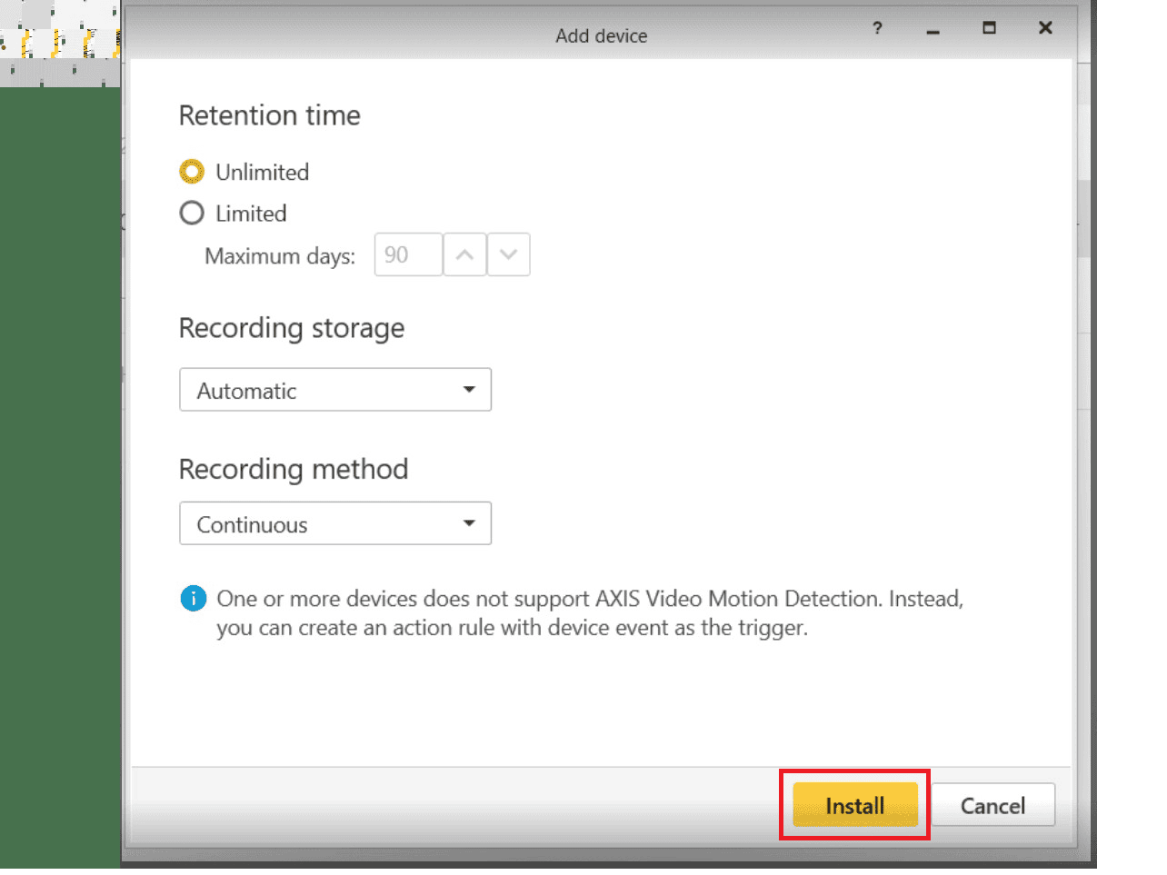
Step 6 : Once Install the devices the camera snapshot will show :
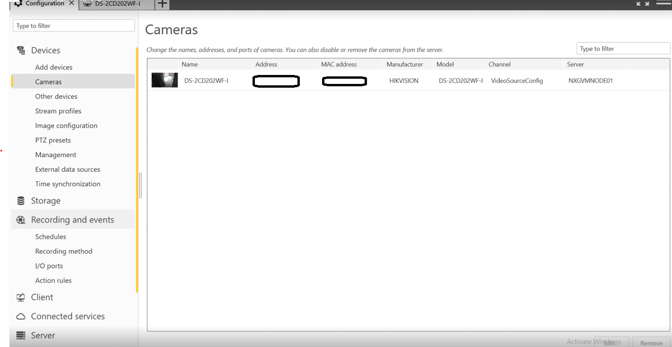
Camera will added Successfully.

Step 7 : Click the + plus button and click the Live View :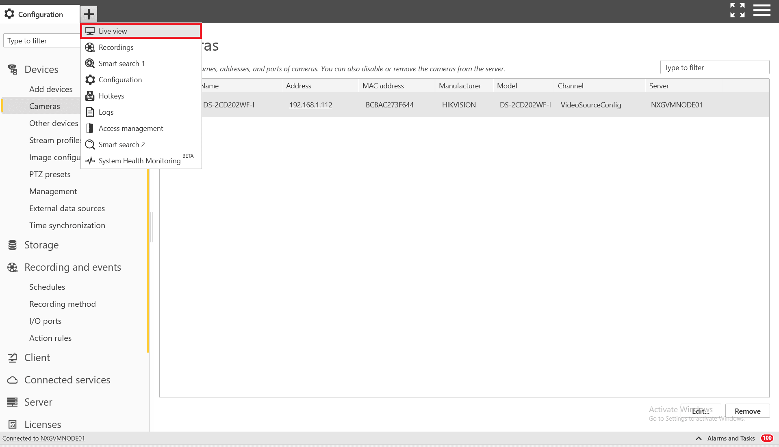
Open the Live View :
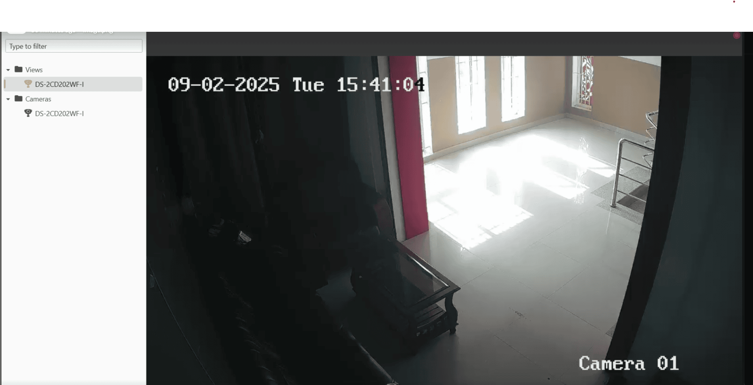
To make playback to be worked, enable the recording in the device level, refer the screen shot.
Step 8 : Click to Recording and Events and open Recording methods :
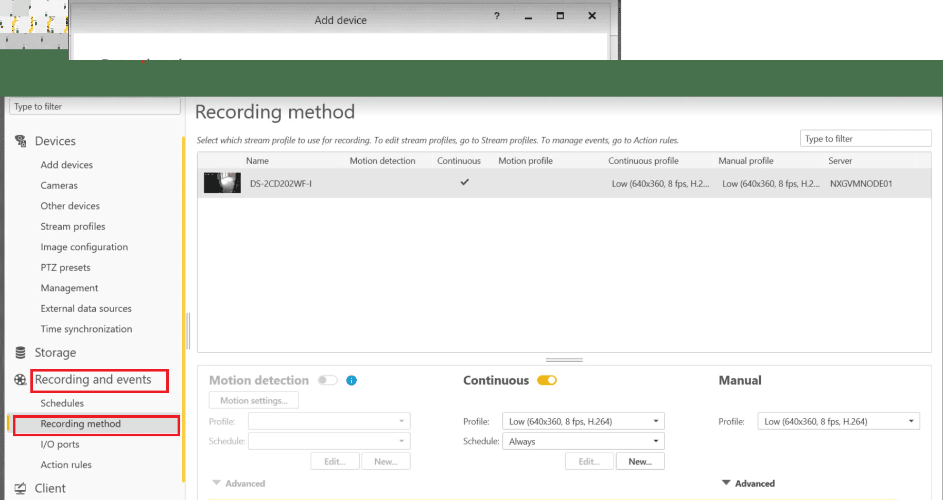
Step 9 : Click the + plus button and click the Recording View :
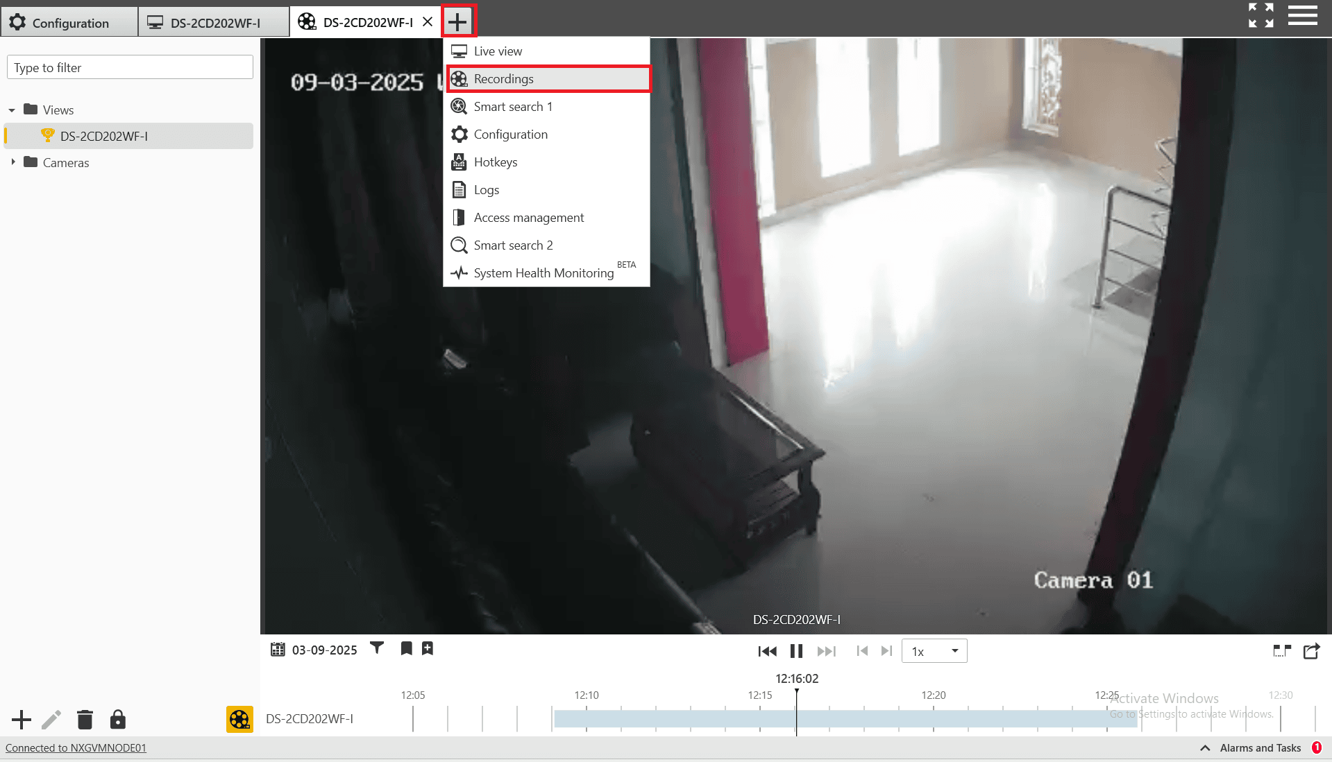

3. Verify Streaming and Events in AxiscamerastationPro client

➤ Step 1: Launch Application
- Open the installed AxiscamerastationPro client from your desktop or start menu.

➤ Step 2: Connect to Device
- Enter the IP address, username, and password of the AxiscamerastationPro unit.
- Click Connect.

➤ Step 3: Verify Live Stream
- Navigate to the Live View tab.
- Confirm the live video feed is working as expected.

➤ Step 4: Verify Events
- Go to the Events or Logs section.
- Confirm that real-time motion or intrusion events are being logged correctly

image
Note: Above steps are essential to validate the device is online and is in working state.

Axis camera station Pro Integration in GCX-ONE
1: Add Axis camera station Pro Parameters to GCX-ONE:
Parameter Type : string
Parameter Name : AxisCameraStation_Device_Custom_baseUrl
Parameter Value : https://acsproxy.nxgen.cloud/
Steps to add custom property:
Step 1: Login to GCX-ONE
Step 2: Navigate to configuration app
Step 3: At service provider level, click on edit button under overview tab
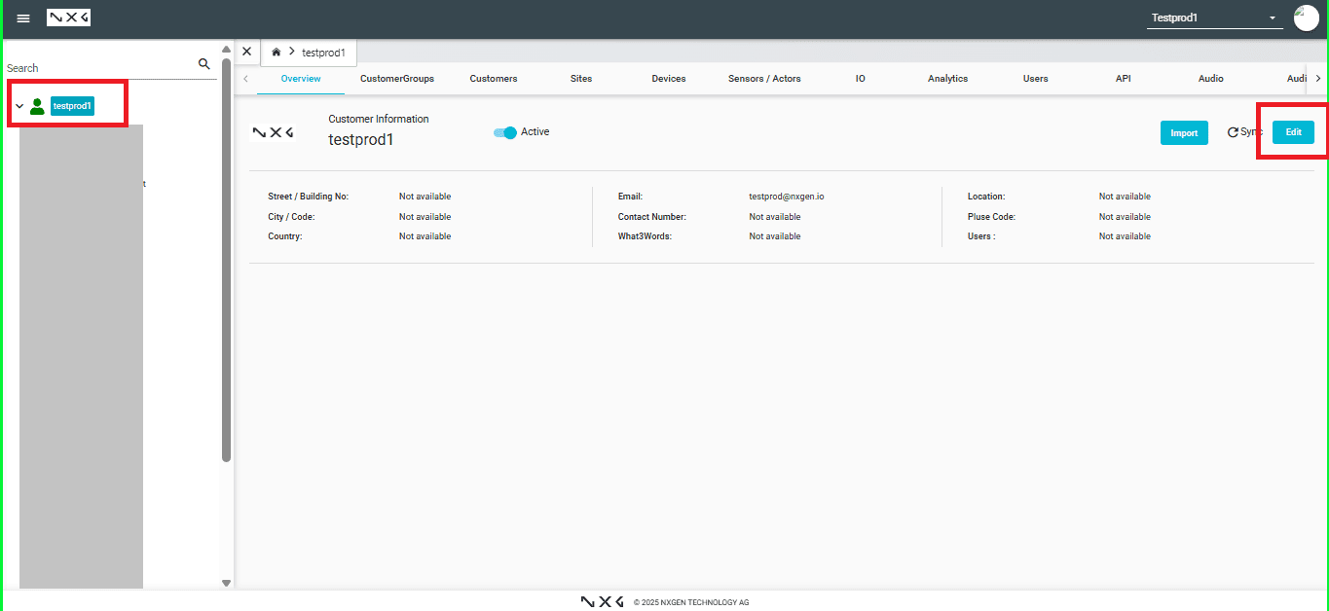
Step 4: Click on additional settings tab->Custom property
Step 5: Scroll down and click on the "Add +" button
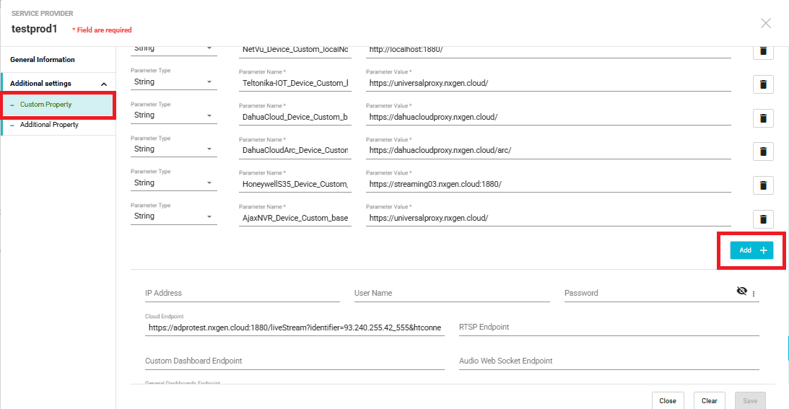

Step 6: Enter parameter name and value as mentioned above
Parameter Type : string
Parameter Name : AxisCameraStation_Device_Custom_baseUrl
Parameter Value : https://acsproxy.nxgen.cloud/
2: Add AxisCameraStationPro Device Under the Required Site
Go to the Configuration section in GCX-ONE.
- Select the target site under which the AxisCameraStationPro device should be registered.
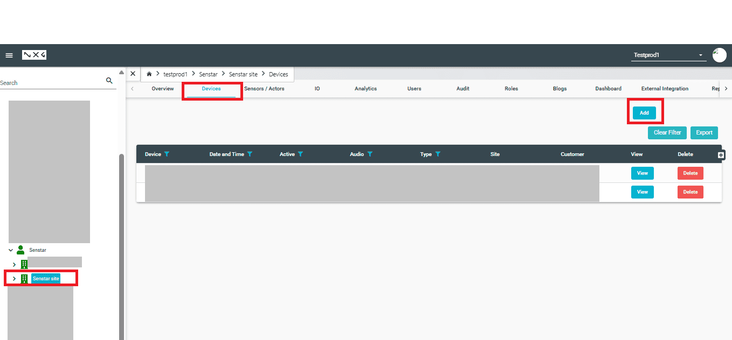
2 Navigate to Devices → Add New Device.
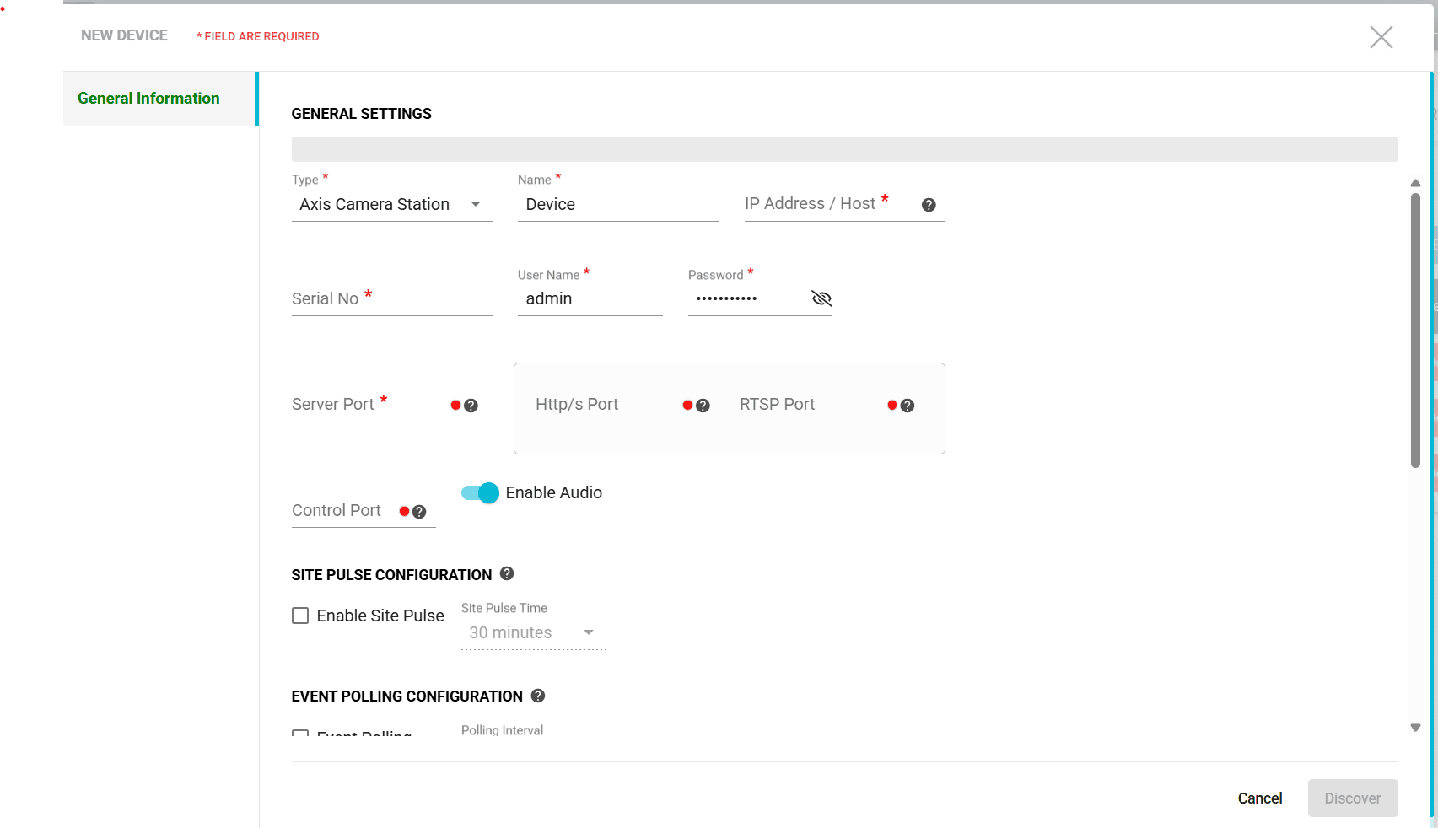
3. Fill in the following details:
  - Device Name: e.g., "Axiscamerastationpro Camera - Gate A"
  - Device Type: Axis Camera Station
  - IP Address/Host: xxx.xxx.xxx.xxx
  - Http/s Port: Default or customized (e.g., 5000)
  - Username: xxx
  - Password: xxx
HTTP Port: for streaming
  - Event Call back implemented for events.necassary webhook need to be created in device level.
Click Save & Verify to confirm that the device is reachable and data (stream/events) is being received.
Live Stream:
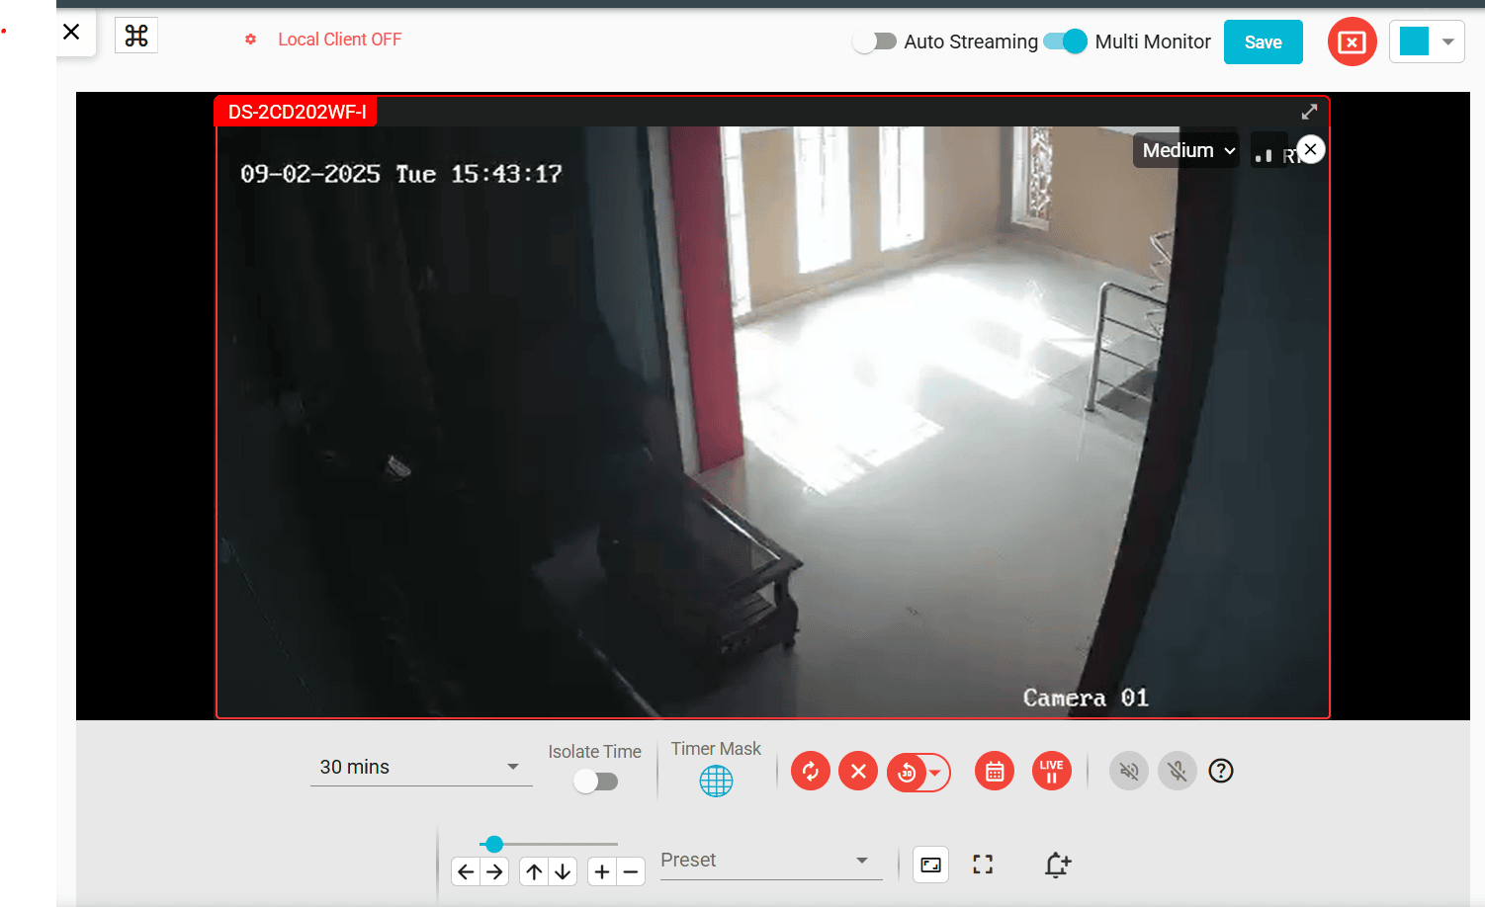

Events In Video Activity Search and Device Dashboard:

CONFIGURING Axis Camera Station Pro for Alarms

- Create event rules at the device level

  - Log in to the Axis device web interface.
  - Go to Action → Rules.
  - Define the conditions (e.g., motion detection, input trigger, tamper alarm).
  - Set the corresponding actions (e.g., send notification, trigger output, record video).

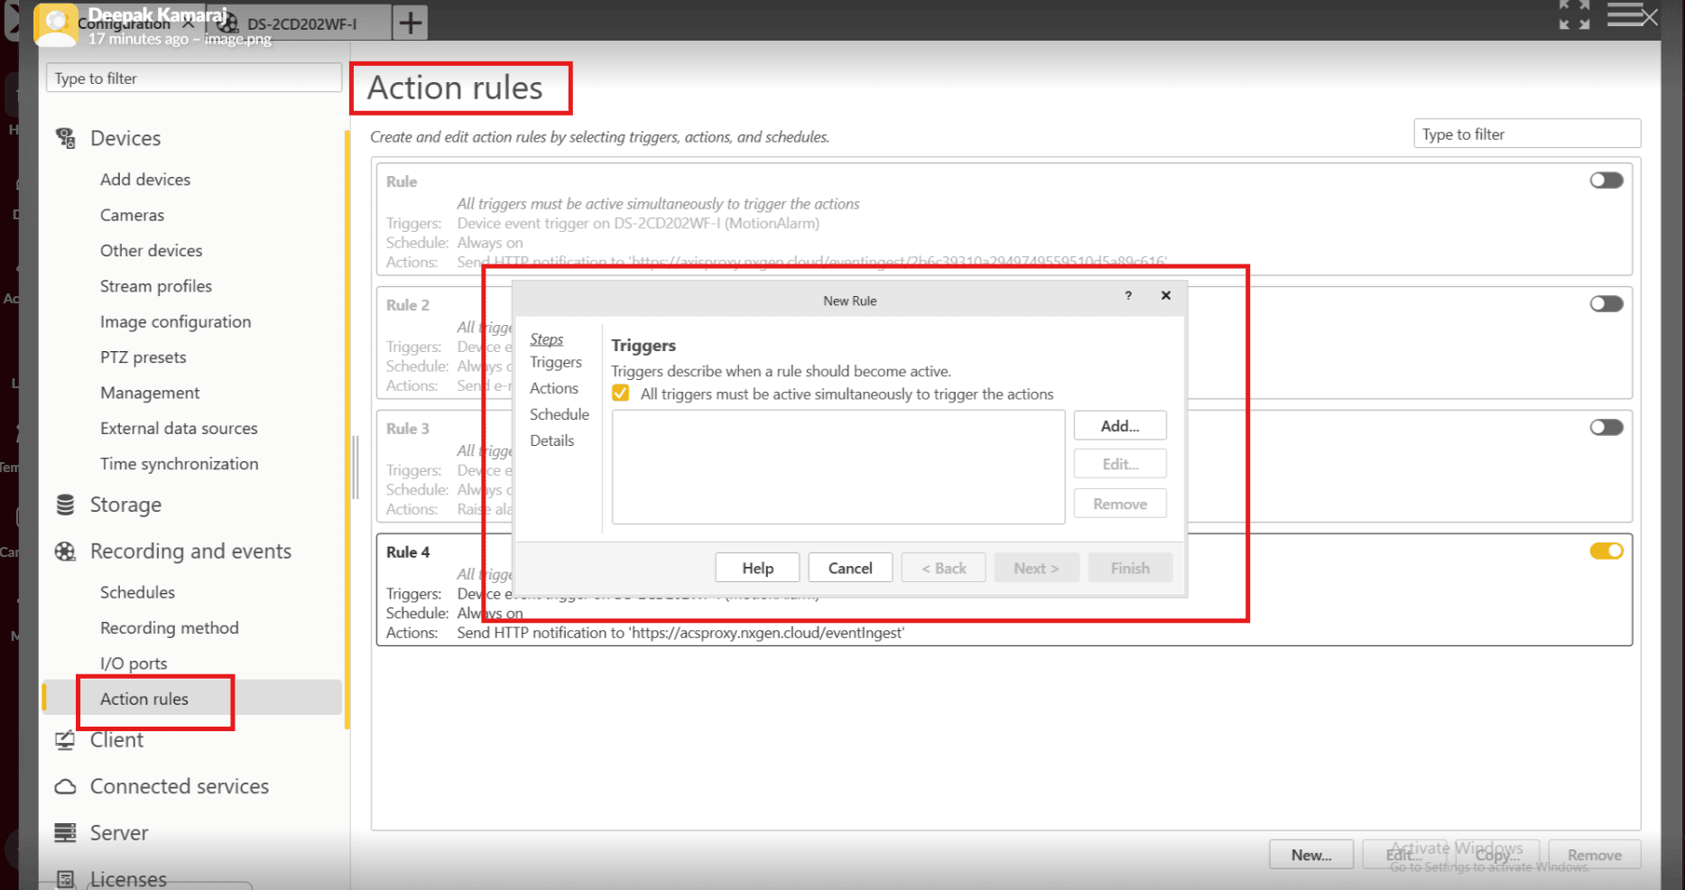

Step 10 : Click the device Events and Click ok :

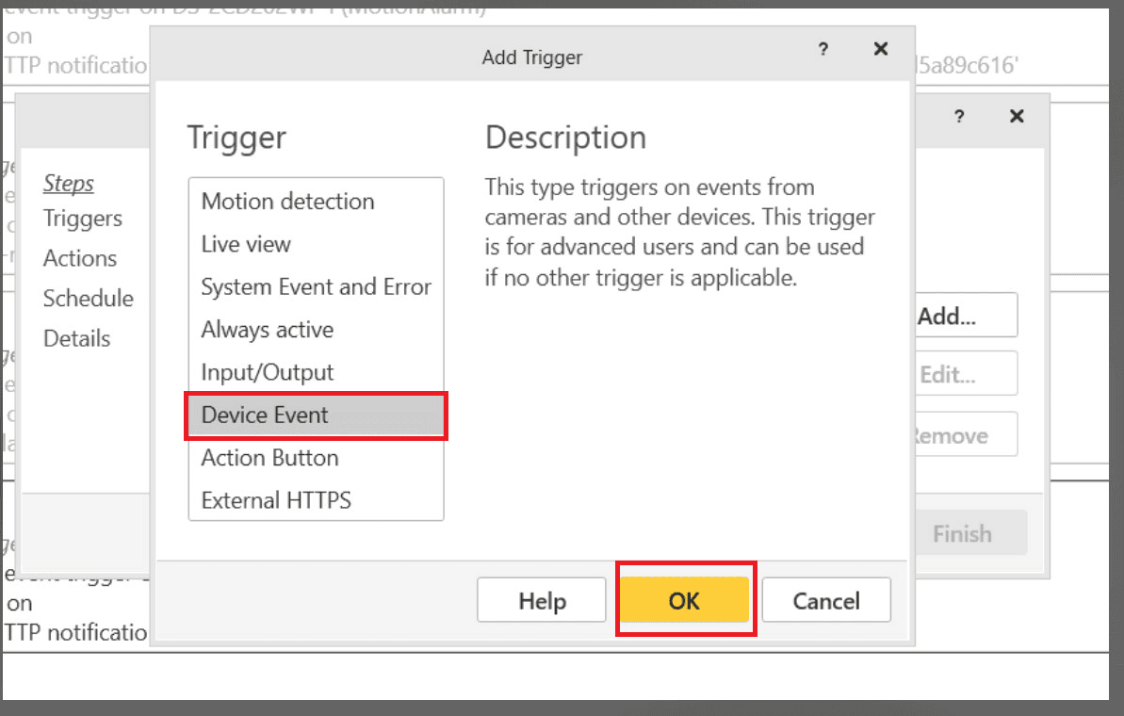
Step 11 : open the popup Configure device events trigger and click ok :
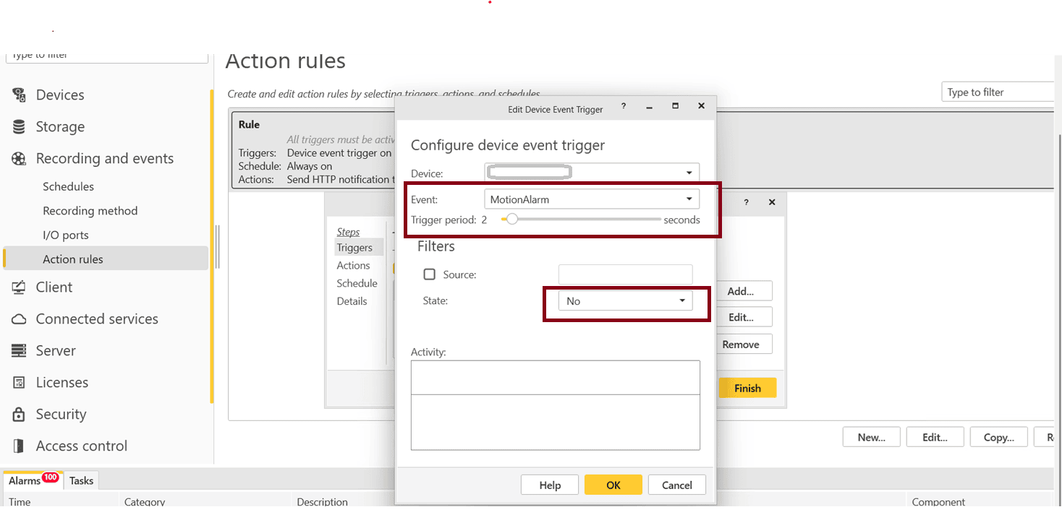
Events : MotionAlarm
State :No

- Add a webhook to trigger events

  - In the device event rule, configure an Action: Send HTTP Notification (Webhook).
  - Provide the Webhook URL (your server/application that will receive the event).
  - Include authentication headers or tokens if required.
  - Save and test the rule to confirm events are being sent.

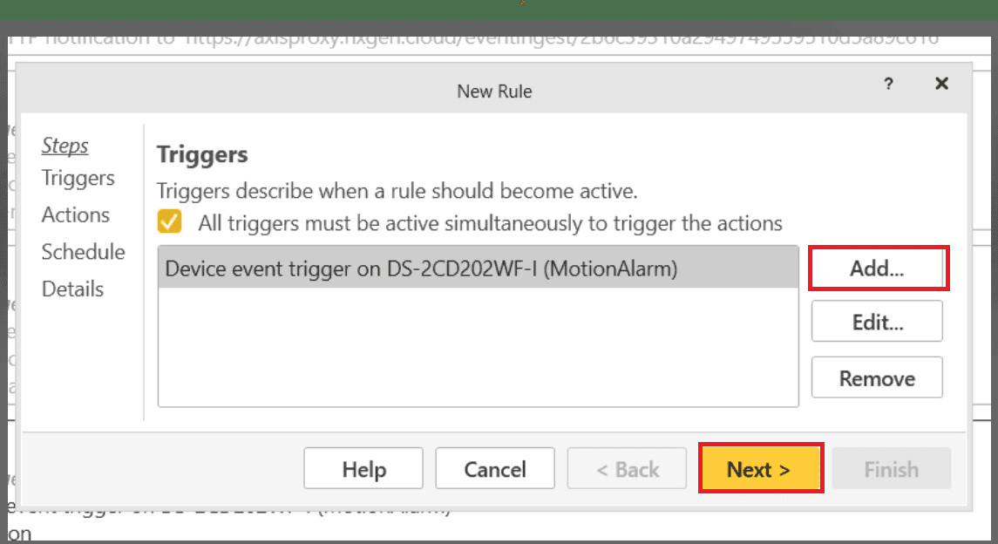
Create Webhook for events :
Step 12 : Open the pop up Click to Send HTTP Notification and click ok :
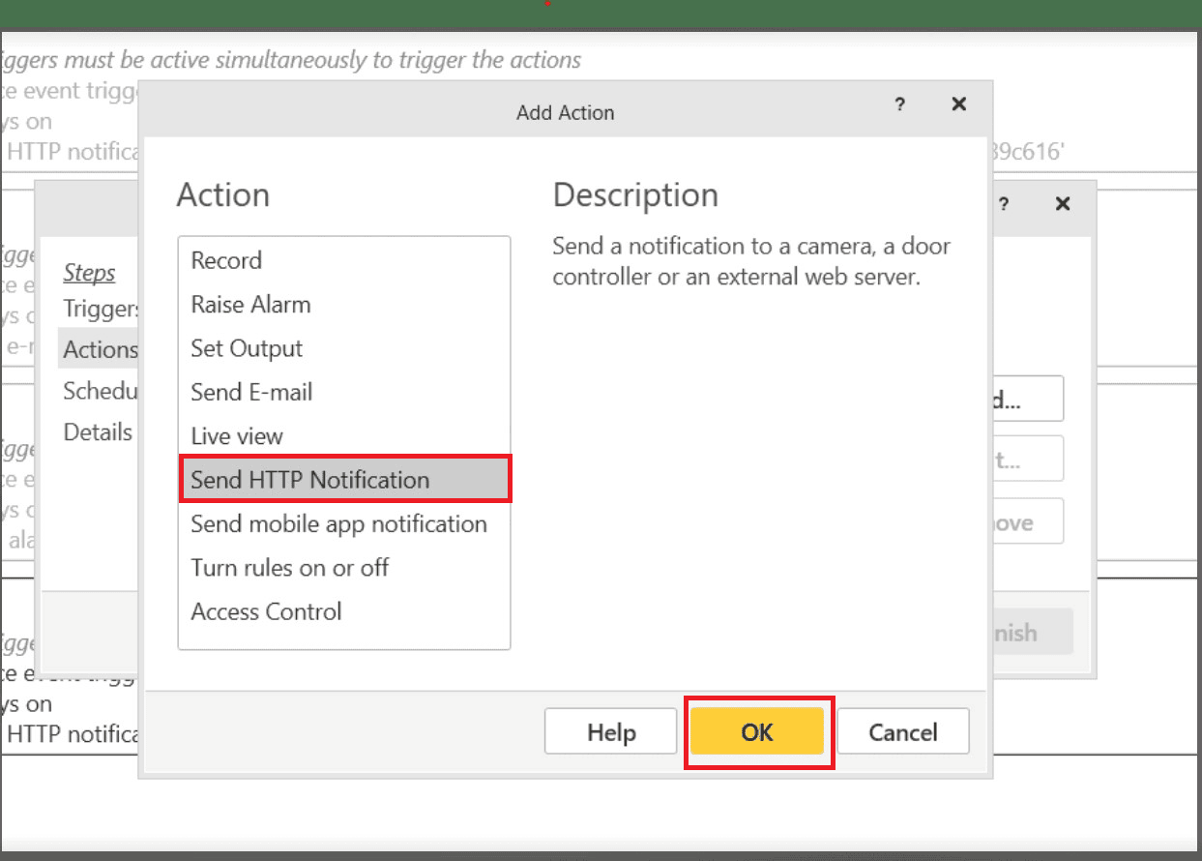
URL : https://acsproxy.nxgen.cloud/
Method : POST
Content type: application/json
authenticationToken : is the deviceguid of GCX-ONE.
you can get the deviceguid from 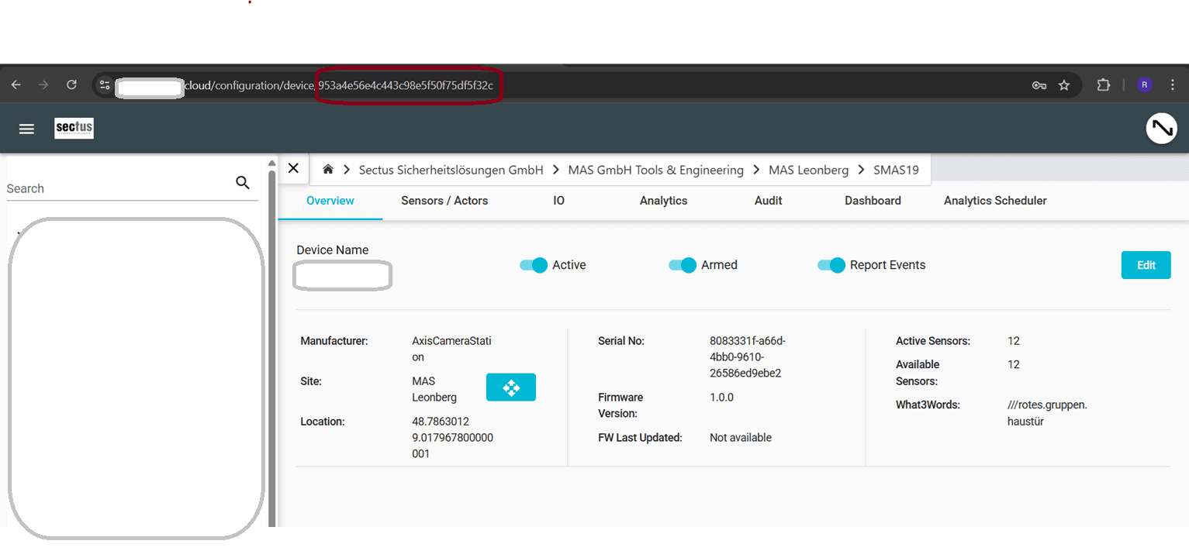
or we can get from ,device edit pop up "unique reference Number"
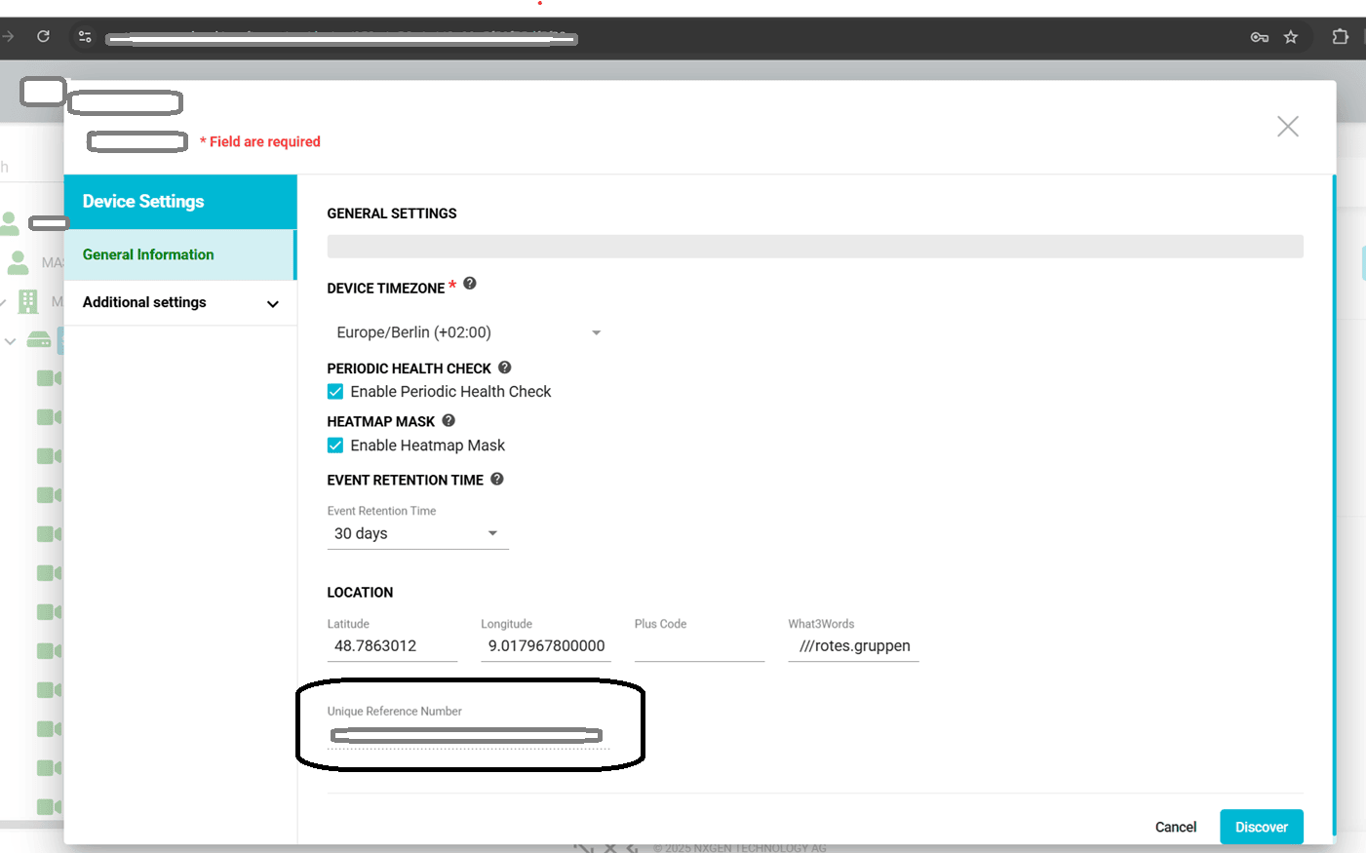
GCX-ONECamId : is the sensorguid of GCX-ONE. You can get the sensorguid from the
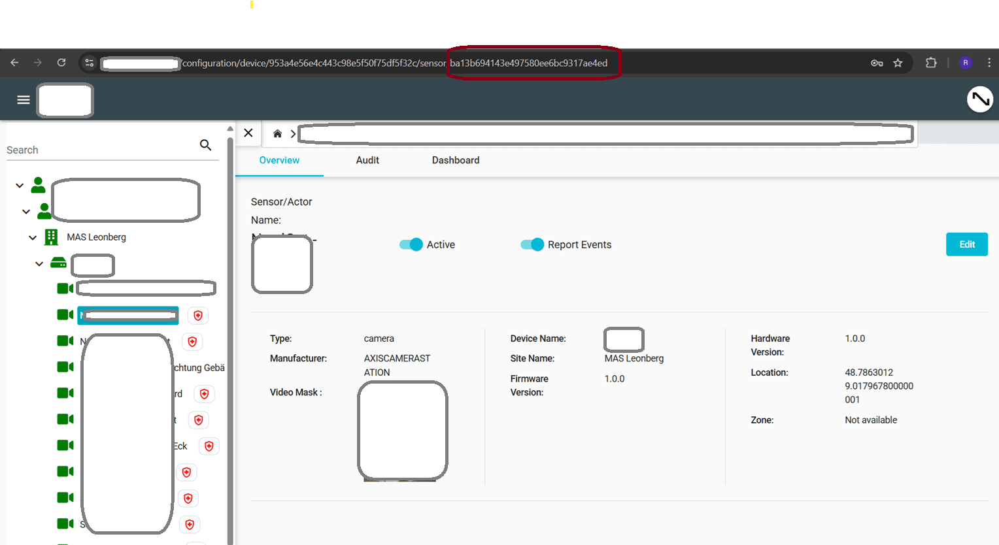
or we can get from, sensor edit pop up "unique reference Number"
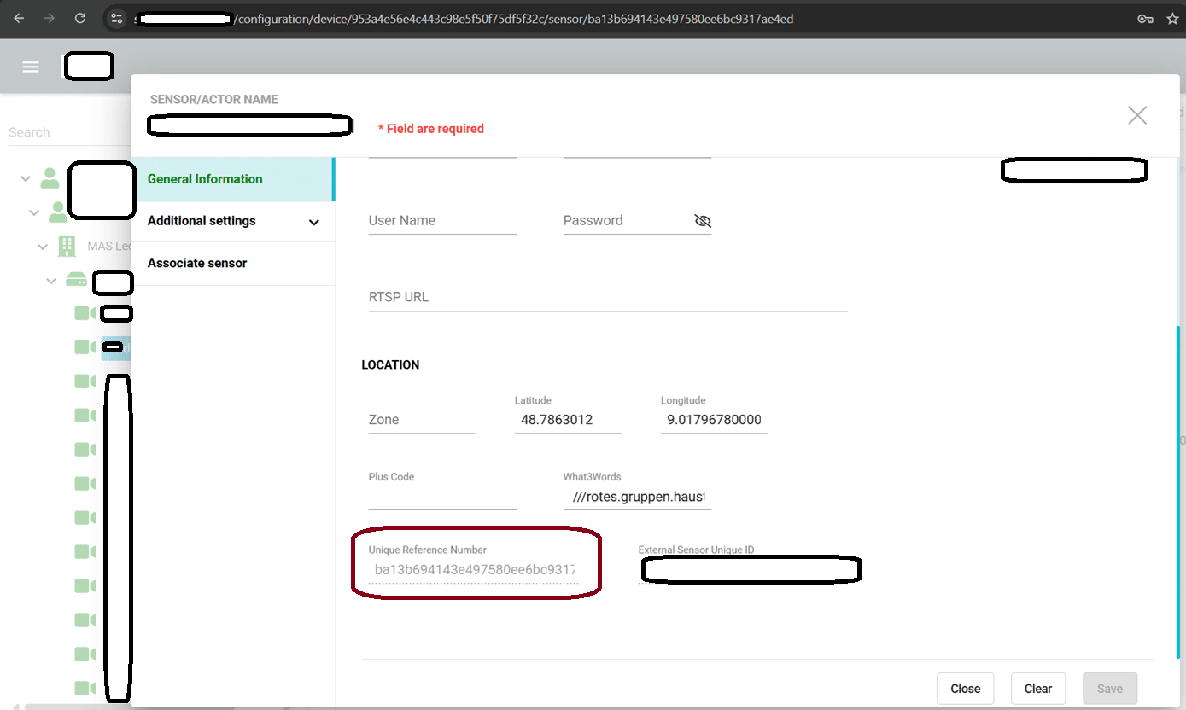

Body:
{
"initialRequest": {
"payload": {
"type": "NOTIFICATION",
"authenticationToken": "5654974ab97f48a1b16a74472864e195",
"notifications": [
{
"event": {
"type": "ALARM_TRIGGERED",
"GCX-ONECamId":"ba13b694143e497580ee6bc9317ae4ed",
"cameraId": "$(TriggerData.SourceId)",
"timestamp": "$(TriggerData.TimeUtc)"
}
}
]
}
}
}

Step 13 : Below the code Copy and paste URL, Methods, Content type, Body click to ok :
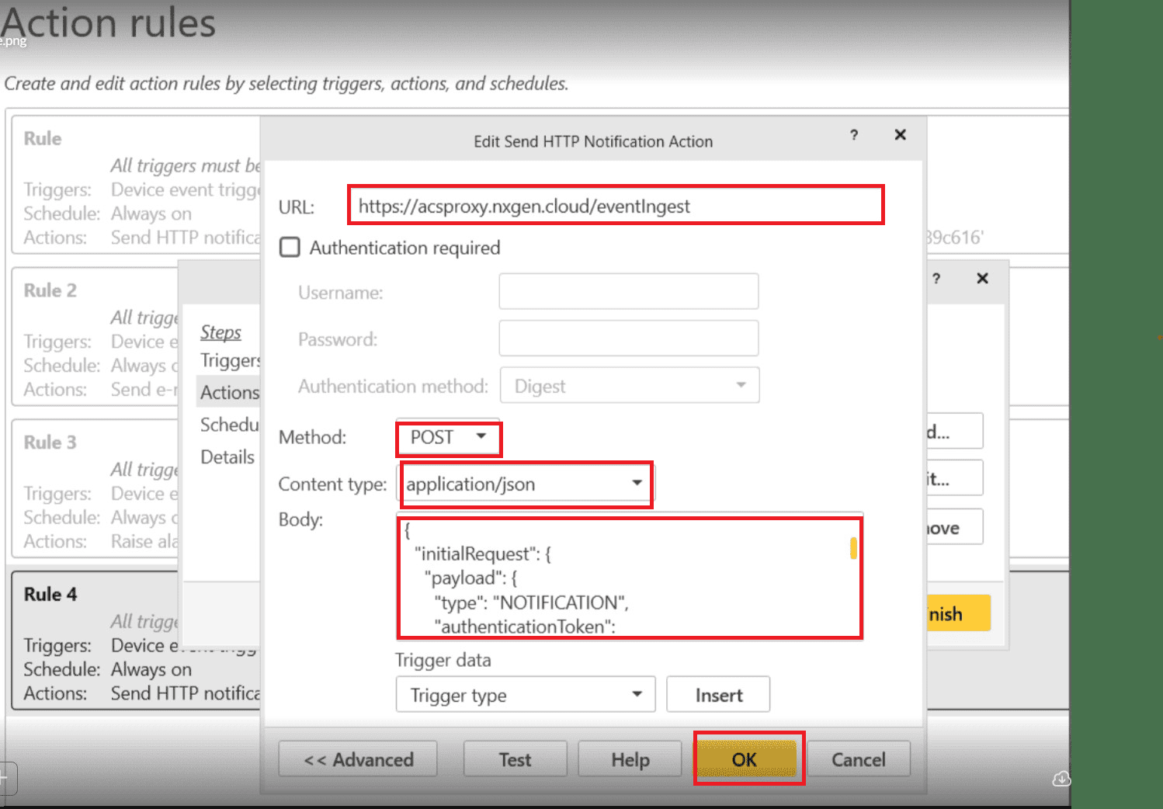

Step 14 : Open the Pop up Edit rules Click to Next :
==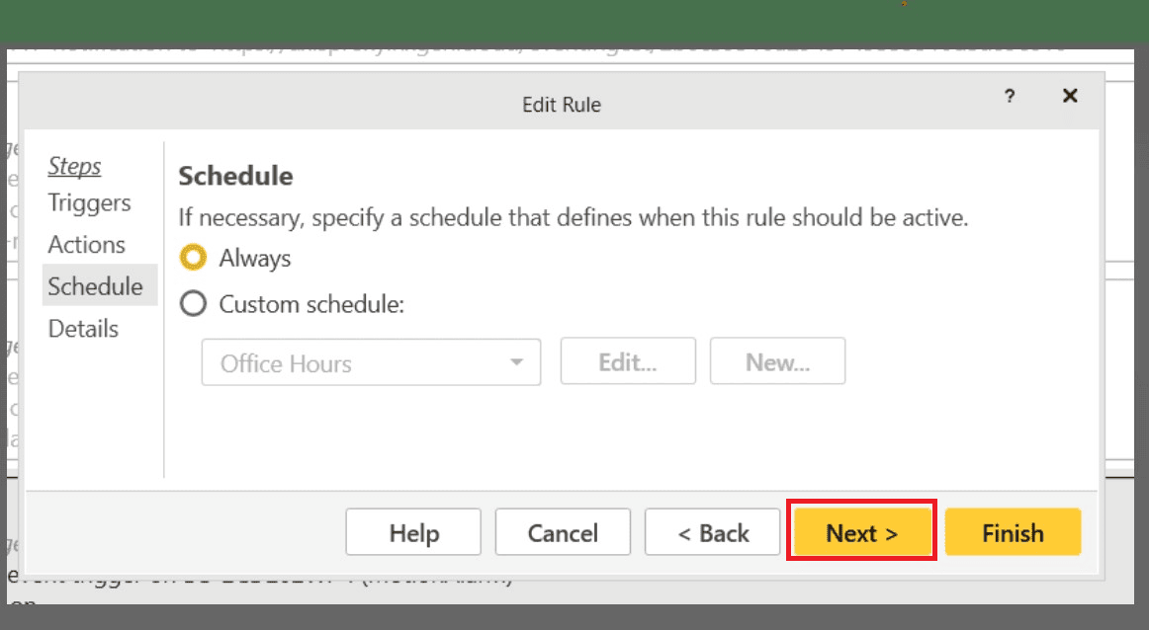
Step 15 : Open the pop up Edit rules and Click to Finish
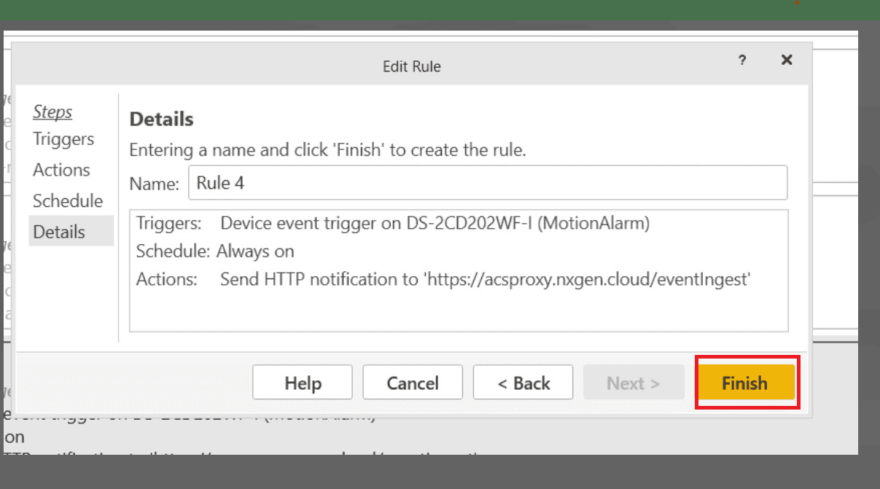
Ports to be opened:
80 , 443 , Default port for ACSpro 29204

